C PROGRAMMING – DATA STRUCTURES

1. Write a c program to implement the SINGLY LINKED LIST with the following operations:
2. Insert an element into the list [ beginning, middle, last].

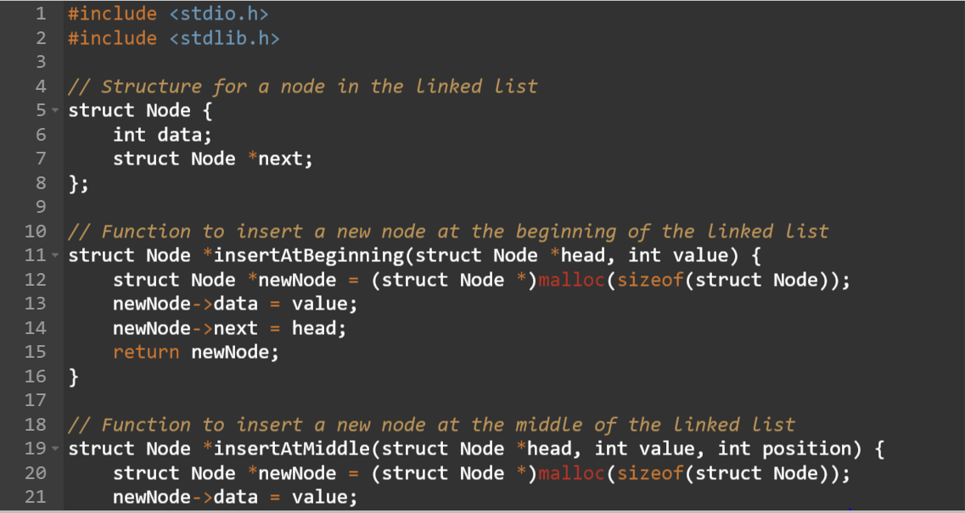

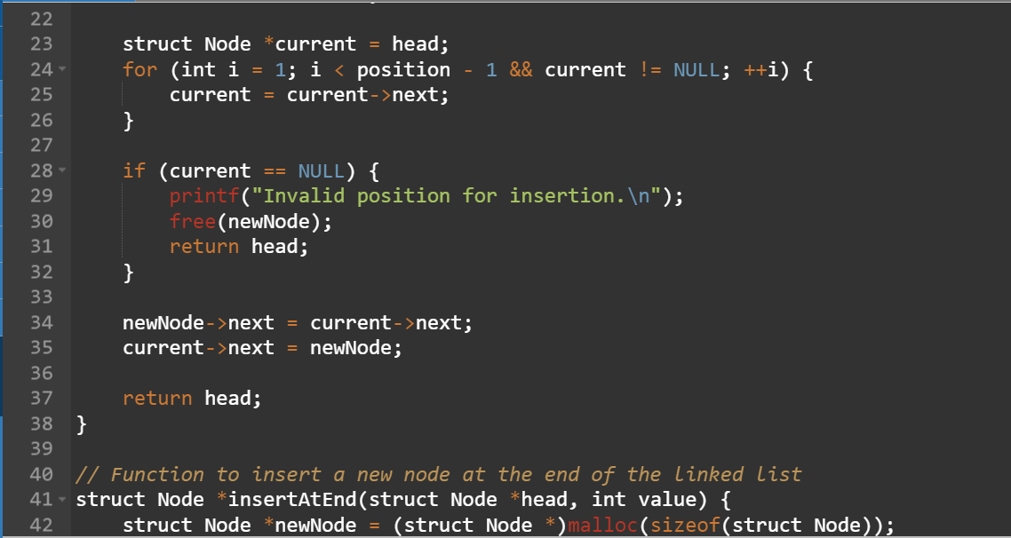

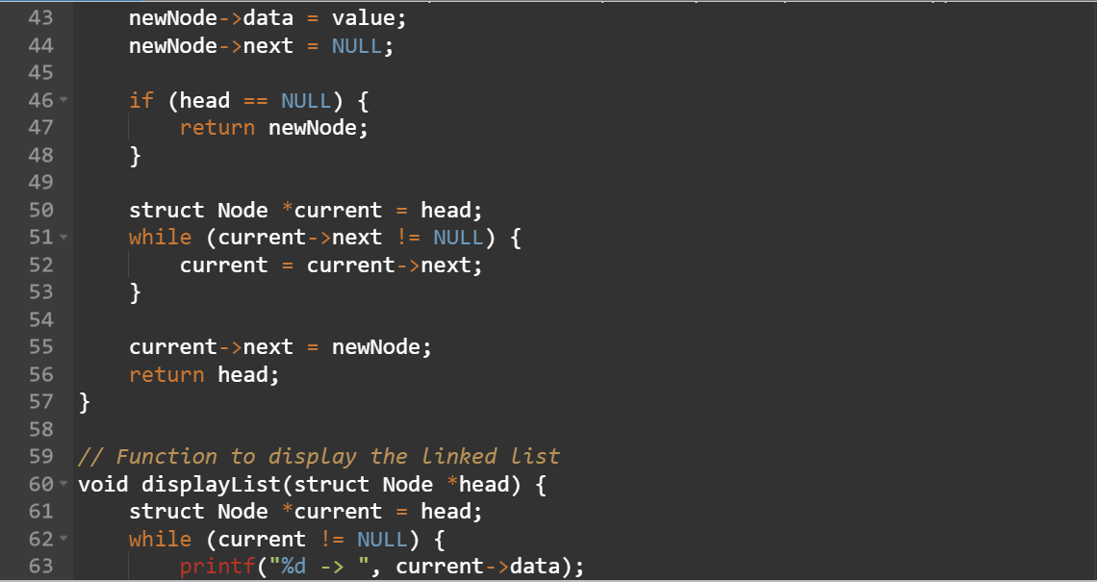

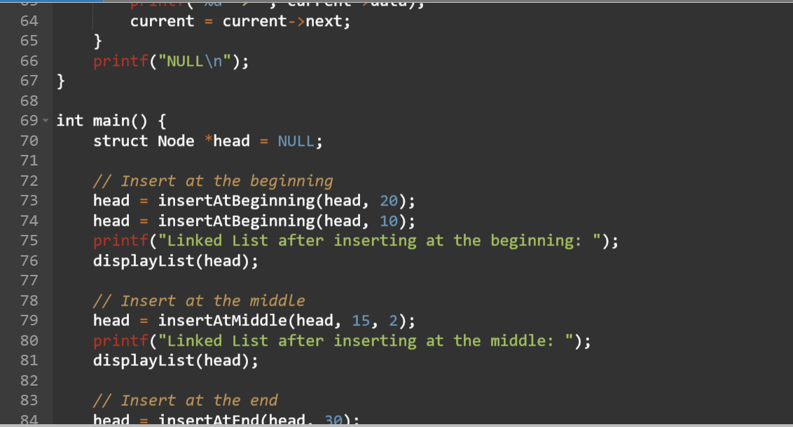

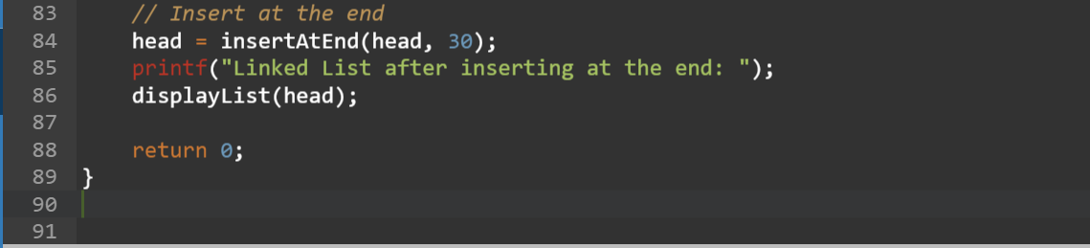

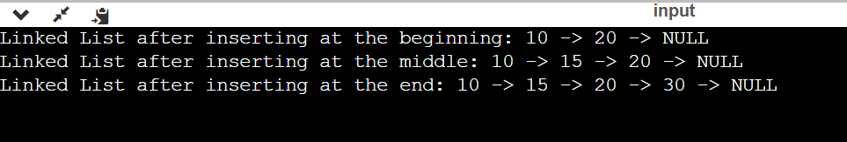

1. Delete an element into the list [ beginning, middle, last].

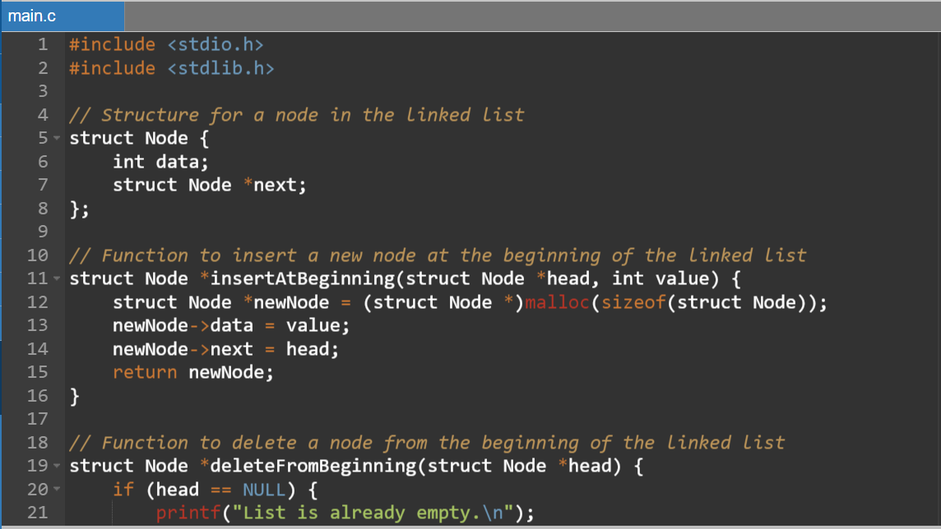

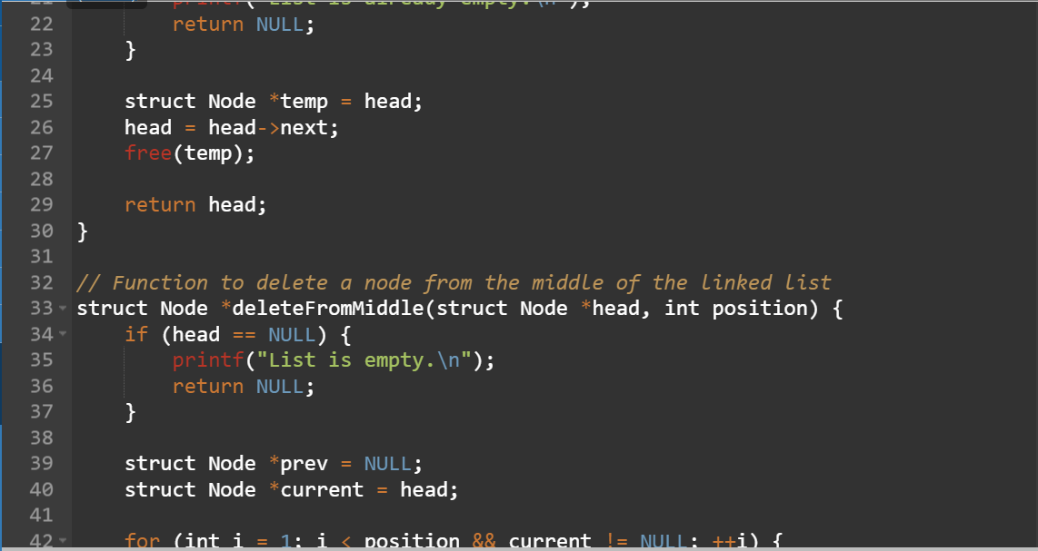

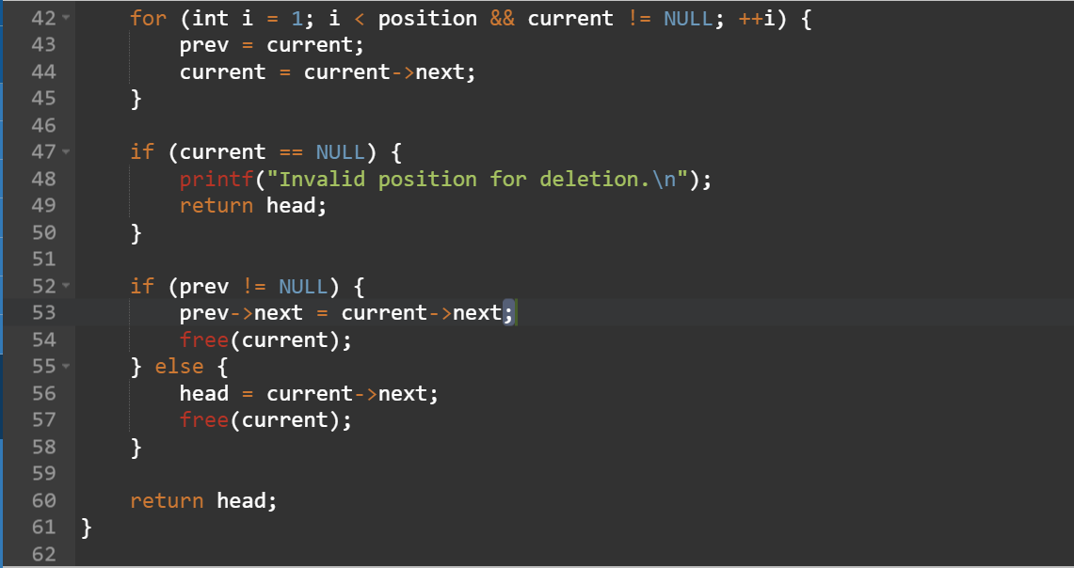

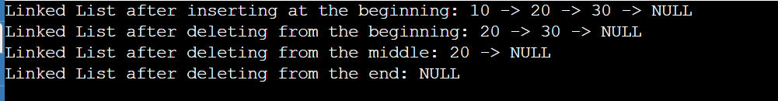

1. Search for an element in the list.

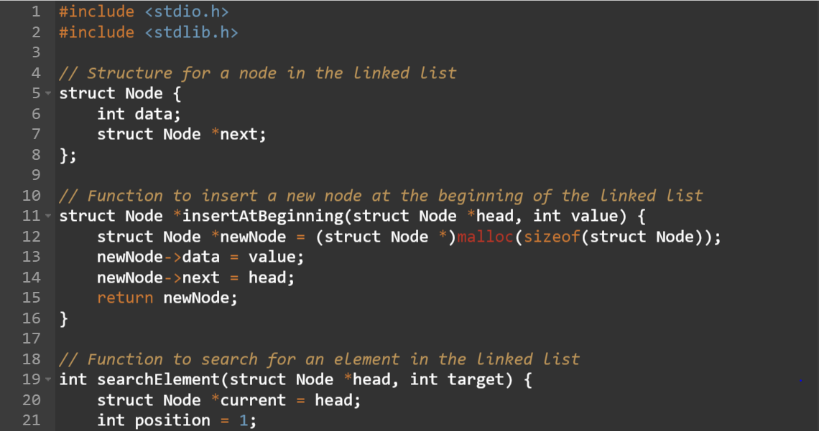

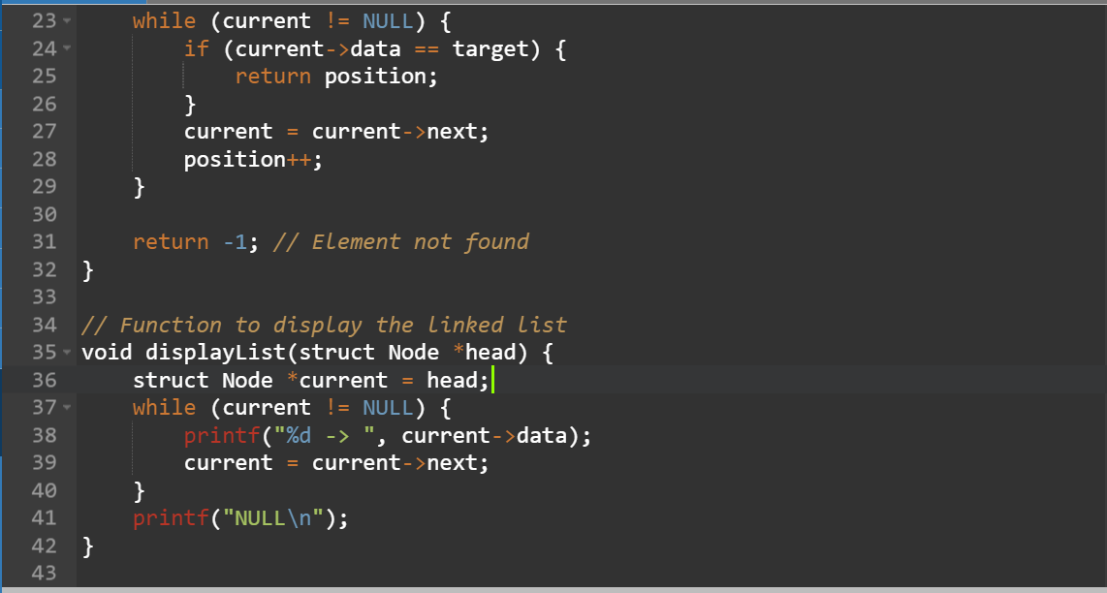

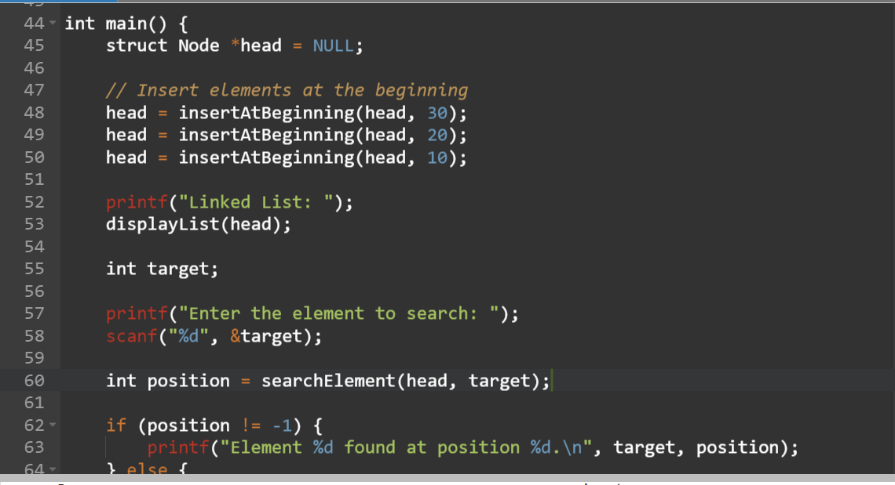

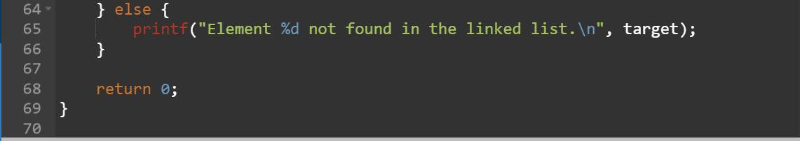



1. Display the elements.

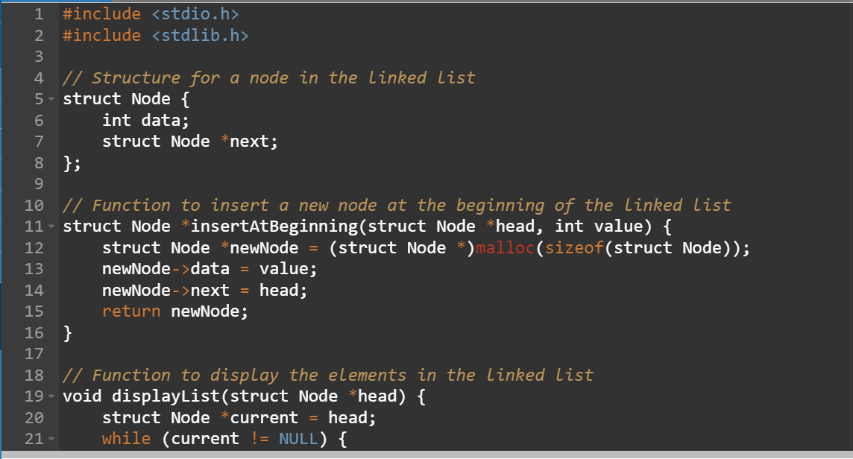

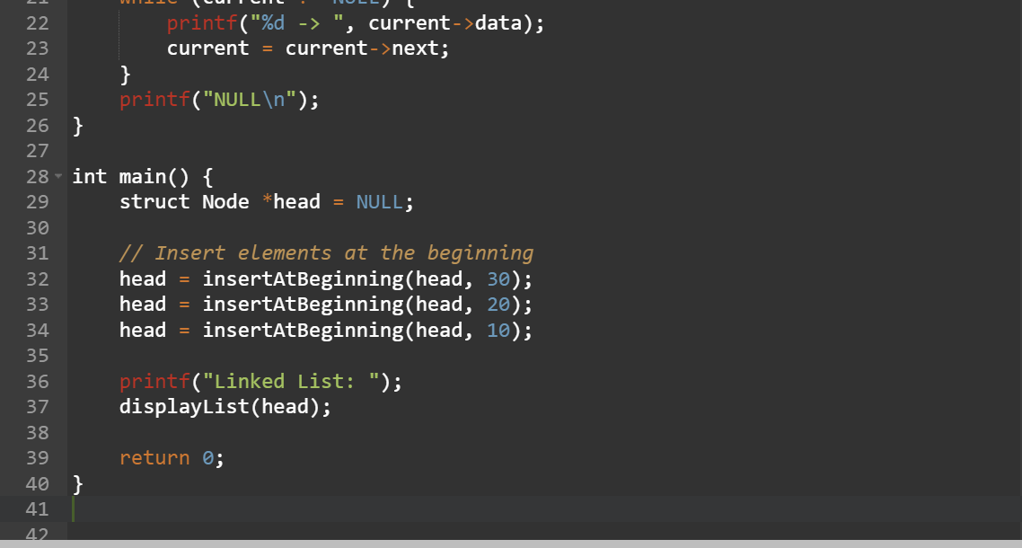



1. Write a c program to implement the stack data structure with the following.
2. Pop an element into the list [ beginning, middle, last].

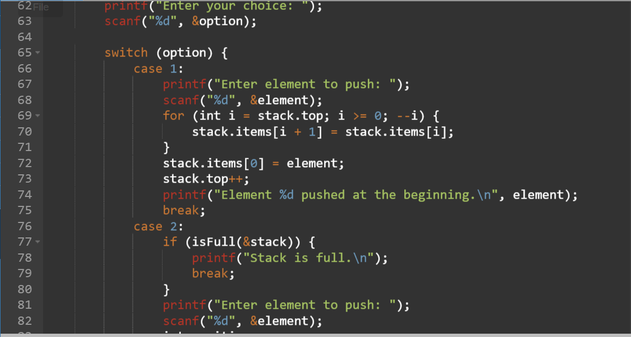

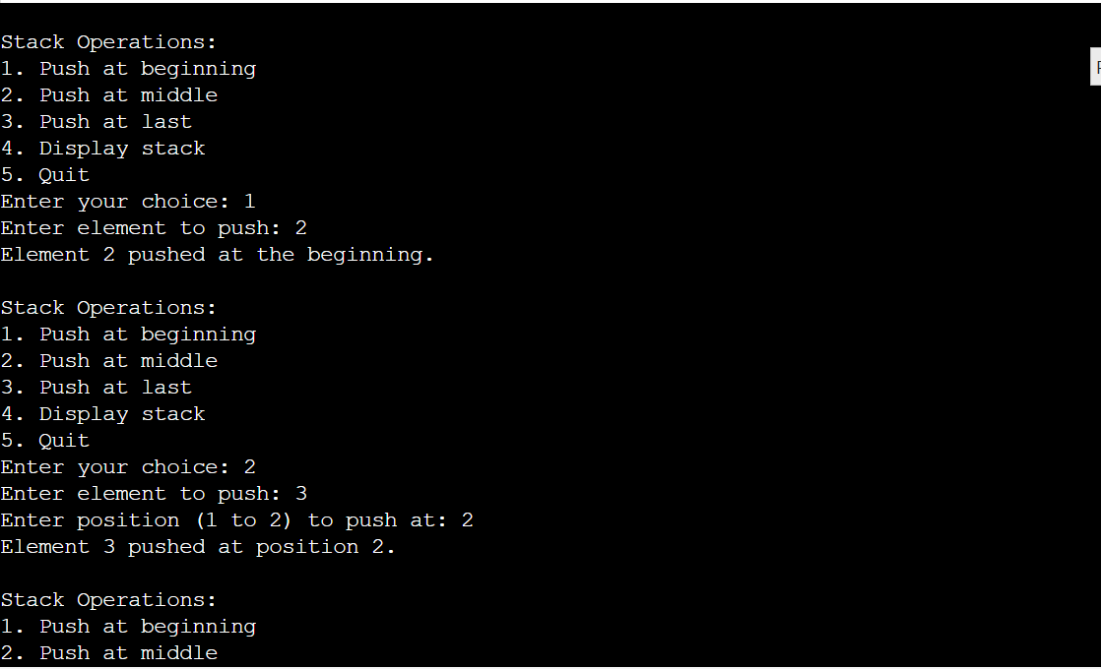

1. Search for an element in the stack.

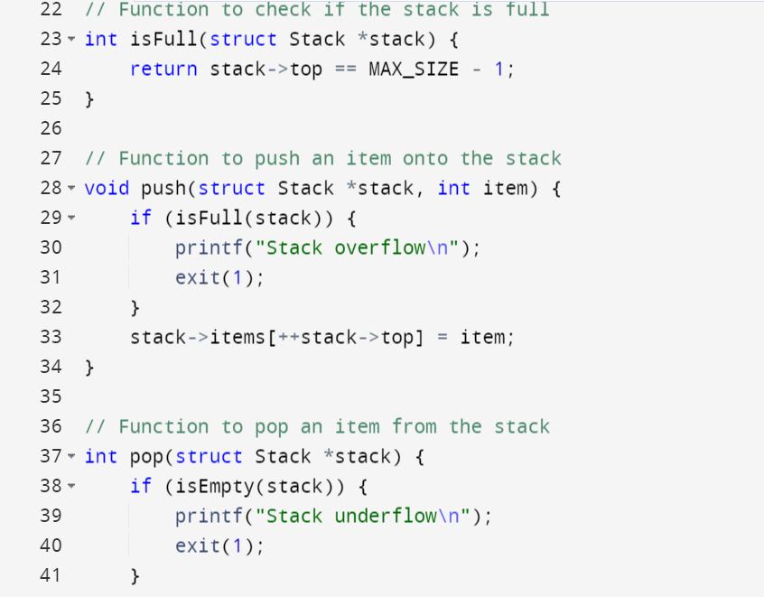

1. Display the stack.

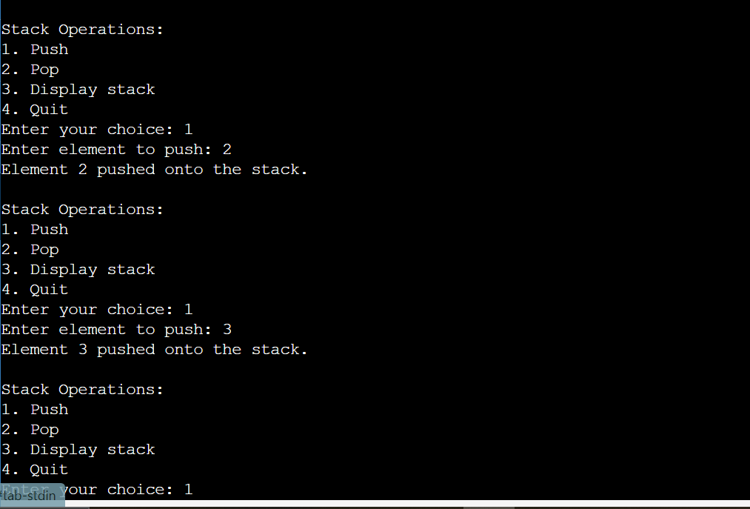



1. Write a c program to implement queue data structure with the following operations.
2. Enqueue
3. Dequeue
4. Display

1. To convert infix to postfix using stack

1. To evaluate the given expression using stack.

